SUBJECT | AUTUMN 1  School Theme: Brilliant Books  (7 weeks) | AUTUMN 2  (7 weeks)
LITERACY  In addition to the themes covered her, we will be constantly improving our comprehension and inference skills using written comprehensions, guided reading sessions and group discussion.  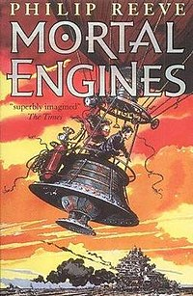 | Book Focus:  Mortal Engines / My Diary – the Titanic  We will be focusing on improving our descriptive and creative writing skills in both prose and poetry, using the Philip Reeves’ futuristic story, Mortal Engines, and a personal tale of the tragedy of the Titanic disaster in My Diary – Titanic.  We will be writing a narrative poem about the Titanic and creating our own mini Mortal Engines side story, focusing on atmosphere and dramatic effect.  Spelling, Punctuation and Grammar -  As spelling, punctuation and grammar is now an important element of the curriculum, and is also tested during SATs in summer, we will be looking at new grammar rules (year 5), revising our grammar skills (year 6) and examining previous test papers to increase our confidence when tackling the SATs Spelling, Punctuation and Grammar paper (which contains its own idiosyncrasies and particular way of answering the questions successfully). We will also, of course, focus on the real reason we are studying English grammar – to be successful, accurate, lively and interesting writers. | Stories from English Literature  Nearer Xmas, we will be reading the classic story, Scrooge by Charles Dickens, and producing our own Victorian diary based on the events Scrooge experiences on Christmas eve.  Poetry:  We will create some poems using metaphor and simile in relation to ancient standing stones, and revolving around the theme of ‘eyes’ linking in with some artwork we are going to produce.  Formal Letter Writing  We will learn to write in a formal and informal manner, writing ‘thankyou’ letters to Brancaster our fieldtrip. We will learn to write a formal letter of complaint, and find out about persuasive techniques in writing. We will discuss the ways in which we can adapt our writing in relation to the level of formality required to meet its purpose.
NUMERACY  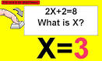 | Maths planning based around the White Rose Maths Mastery Plan for mixed years groups.  Place Value  Four Operations  Statistics  Measurement – Perimeter , Area and Volume  We will use our mastery approach, whereby the children will take more ownership of their learning by selecting the appropriate level of challenge – along with guidance from the teacher.  In addition, we will be focusing weekly on strong, quick formal calculation skills and efficient mental maths methods - with learning times tables off by heart an essential element of this.

HISTORY | Stone to Iron Age:  We will investigate the ‘Pre-history’ of Britain - looking at Stonehenge, it’s construction and purpose.  The Iron Age –  We will be looking at tools and technologies and how they compare to today’s technology. | 
RE
  What do I believe in?  How do I decide what influences me?  What do Christians believe?  Why?  Harvest festival  Why do people celebrate harvest?  We will also be taking part in our Harvest festival at the village hall. | Festivals:  Theme -Incarnation:  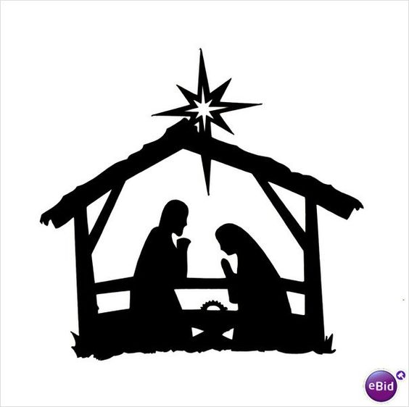  We will be asking three questions:  Who was Jesus?  What is a messiah?  What is a savior?
SCIENCE  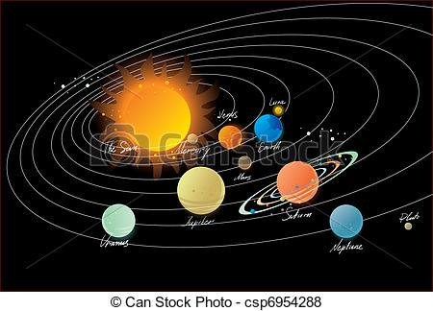 | Earth and Space –  We will be investigating our own solar system We will find out the mechanisms which result in earth having day and night, and find out just why we have a leap year every 4 years. We will look at those questions which keep us awake at night – why don’t we fall off the earth if it is spinning, what is gravity, why do I weigh less on the moon?  We will use our literacy skills to gather all this information together and producing a detailed explanation text about earth and our solar system. | A Trip to Mars  We will investigate all those problems which will arise if man is ever to travel to Mars. We will use our space knowledge to make predictions about what the conditions will be like and how science can solve those problems.  Forces:  We will also take an introductory look at Newton’s laws of motion and how they describe the forces which will be important in such a trip.
GEOGRAPHY |  | Maps and Mapping  We will be studying maps, atlases and globes and the skills needed to read and design them, along with learning about computer mapping.
ART | Watercolour and Pastel  We will learn to use pastel to create dramatic skies and combine this effect with photography and decoupage to create a standing stones piece of art work in conjunction with personification poetry. | Eyes to the Soul  We will learn techniques in drawing eyes and our artwork will reflect themes related to eyes and what they can show both physically and in a more abstract way.  .
MUSIC   | Ocarina  We will be learning to play the ocarina in class, and learn traditional carols to play at the Christingle service.  We will be listening to The Planets suite by Holst and thinking about how each planet is represented.  Later in the term we will learn about this year’s CASMA concert and begin to learn our performance songs.
MFL  French | We will be following the Rigola French scheme and continuing to improving our conversational French.  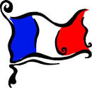
PE     | In the first half of this term, we will be building upon and developing high level skills in hockey and tag rugby in preparation for the forthcoming school games inter school events.  Groups will take part in swimming on Monday afternoons, and children will have an opportunity to represent the school in the cluster gala after half-term.  We will be setting personal bests across a range of indoor athletics events which hopefully many children will continue to develop at Friday athletics club.  We will be mountain biking at Brancaster in November.
ICT  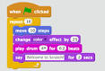 | Safe Internet and Coding  We will be refreshing our safe internet use skills, and developing more complex programming skills using the Scratch programming language.  Graphics:  We will be learning how to edit and manipulate an image and incorporate it into another image. | Computational Thinking:  We will be writing programs to investigate how we can represent artificial computer intelligence using our Scratch skills.

Class 4
2018-2019
Academic Year

