Sharing a shell
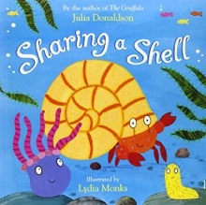
Click here to hear the story being read by Mrs Furness (with a sneaky hello video message at the end!)

Reading
Task 1: Retell the story from the point of view of the crab. These role play masks might help you get into character.

Task 2: Investigate the rhyming patterns on each page of the book.
Have a look at this powerpoint about Ronald the Rhyming Rhino if you need a recap of how rhyming words work.

Task 3: Look at the use of punctuation in the story. When have full stops, commas, questions marks, exclamation marks (etc) been used and why?
You can work through this Popping Punctuation powerpoint to challenge your knowledge on punctuation.

Writing
Here is a booklet with checklists you can use to see what you should be aiming for when you are writing. Scroll through to find the correct year group and you can try to tick the boxes off when you are working on a piece of writing. This checklist is used in school for assessed independent pieces of writing but it can be used at home as a guide.

Task 1: Make a list of the rhyming words in the story.
How many rhyming pairs can you find?
Can you think of any other words that rhyme with the ones you find?

Task 2: Make a list of the words that describe movements in the story, e.g. roaming, romping, rollicking.
Can you think of any more?
‘Doing words’ are known as verbs. Have a look at this powerpoint to learn about verbs.
If you would like to do some more work on verbs you can take a look at these differentiated worksheets and chose the correct level for you.

Task 3: Why is it important to share?
Sharing is a very important life skill. Make a poster that we could use at school to promote good sharing.

Task 4: Have a look at this word/picture matching activity.
When you have matched all the words to the correct pictures, use the words to practice your handwriting.
Task 5: Can you write a story about someone who struggles with sharing and how they learn their lesson?
Your story needs to have a beginning, middle and end. Have a look at this story mountain to help you plan out your ideas.
Remember to use correct punctuation, interesting words and some of the verbs you looked at in task 2.

Topic
Task 1: Look on a map and find the location of your nearest beach.
How would you get there?
How long would the journey take?
Is there any public transport to the beach?
Can you find the timetables and see if you can plan a journey?
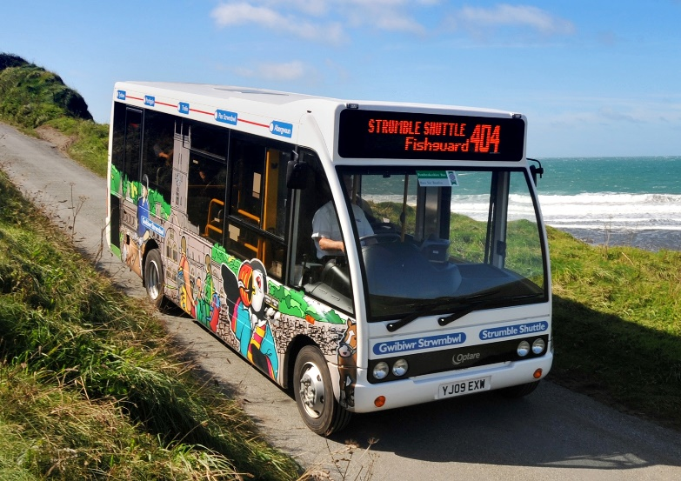
Task 2: Think about people who help you. This could be family members, friends or professions such as Dr’s, policemen etc
What do they do?
What can you do to help them?
What would you like to do when you grow up?
How will you help people?

Task 3: Create your own illustrations of the creatures / places mentioned in the story.
Here is a tutorial about how to draw a hermit crab.
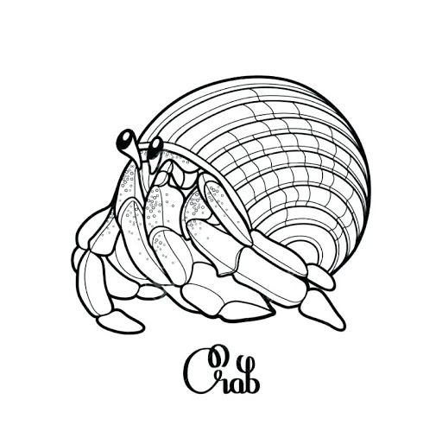

Task 4: Design (and build) a new home for the three creatures to share.
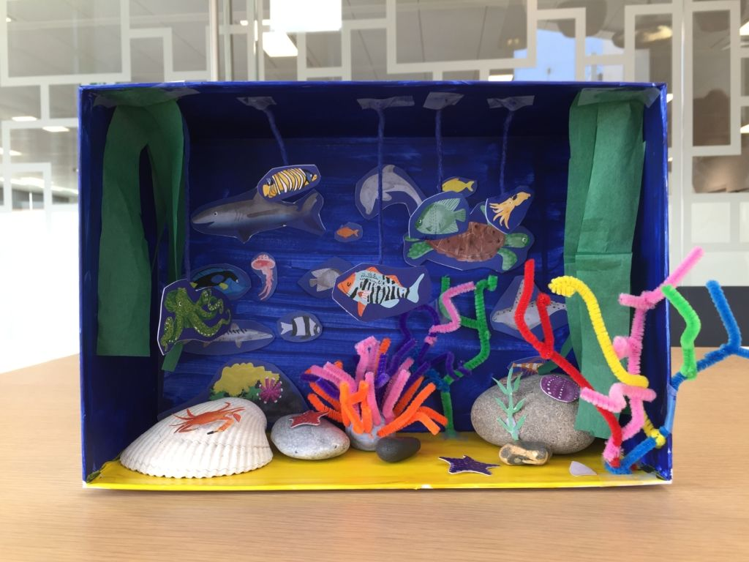
You could use an old shoe box or cereal box as your starting point.

Task 5: Make a list of animals/plants that you might find in seaside habitats.
How many different types of habitat can you find at the coast (beach / rock pools / ocean)?
Here is a powerpoint about coastal habitats.

Task 6: Make a video to retell the story.
Can you include pictures, narration, music and sound effects?
You could just record yourself reading the story in an exciting way.

