Seal Surfer
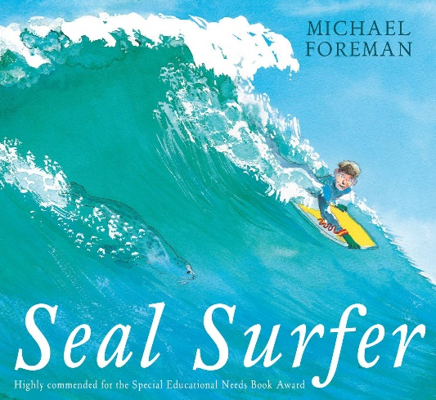
Click here to hear the story being read by Mrs Furness

Reading
Task 1: Retell the story from the boy's point of view. Or from the seal’s point of view.

Task 2: The author uses lots of different verbs to describe movement in the story. Can you find them all?
We looked at verbs last week, if you are unsure refer back to 29.06.20 writing task 2.

Task 3: Which was your favourite season in the book? Explain why?

Writing
Here is a booklet with checklists you can use to see what you should be aiming for when you are writing. Scroll through to find the correct year group and you can try to tick the boxes off when you are working on a piece of writing. This checklist is used in school for assessed independent pieces of writing but it can be used at home as a guide.

Task 1: Can you write your own story which has different events taking place in each season?
You could fold a piece of paper into 4 pieces and use each section as a different season.
Plan out your story using the four boxes and think about what could happen in each season.
Use the Ros Wilson writing booklets above to make sure you include all of the important things for your writing.

Task 2: The seals 'twist', 'turn' and 'corkscrew' into the depths of the water. Can you find any synonyms for these words?
A synonym is a word or phrase that means exactly or nearly the same as another word. Eg, small, tiny, petite

Task 3: Could you plan and write a new story about an animal who saves a person in danger?
Use this story planner to help you plan out your ideas.

Task 4: The seal 'basked' in the warm sun. Can you think of other words that have the same meaning?
Use a thesaurus if you aren’t sure.

Task 5: Here are some handwriting sheets based on seasons you can complete.

Topic
Task 1: Why do we have seasons?
Can you find out and teach somebody else about them?
Have a look at this powerpoint on seasons to get you started.

Task 2: The seal in the story grows older and has a pup of her own.
Think about life cycles of different types of creatures.
Here is the life cycle of a sea turtle.
Can you draw out one of your own? You could use this template or draw your own.
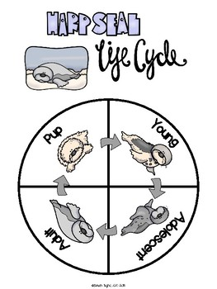
Task 3: Look at the different shades of the same colour in the illustrations (e.g. the greens in the sea and blues in the sky).
Could you try to mix different shades of the same colour using paint, or blend them together using pens / pencils / crayons?
Task 4: The music of Beethoven plays in the radio in Grandad's old pick-up truck.
Listen to any music by Beethoven?
How is it similar / different to other types of music?
What are your opinions of it?
Here is a link to some Beethoven on youtube.

Task 5: Describe what the weather is usually like in each of the four seasons.
Try out this game about dressing for the correct season.
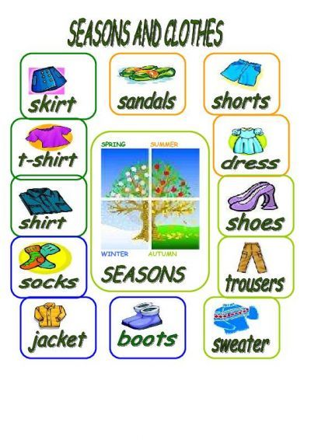
Task 6: Find out about animal charities in your local area.
Can you make a poster to advertise what they do, or plan an event to support them?
