Christmas Card, Mug & Products
Fundraising Project

Dear Parents
This year we are pleased to announce that our school is raising money by taking part in the
RUDOLPH CARDS Personalised Card, Mug and Products Project!
Your child (or children) can design a special picture which can be printed on to their very own packs of Christmas Cards or on a ceramic Mug and even on to a wide range of products from Teddies to Coasters! Perfect for family and friends this coming Christmas Season, as they will be truly unique! You can be confident that buying our cards won't mean harming the world's forests as we only use responsibly sourced FSC card.
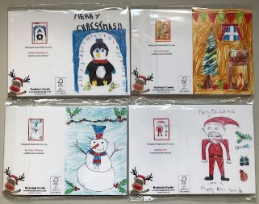
Rudolph Cards Products for 2020
Christmas Cards
Our premium quality, personalised packs of Christmas Cards feature each pupils individual festive design on the front & their name, class & the School name on the reverse. Pack of 12 A6 Cards including envelopes
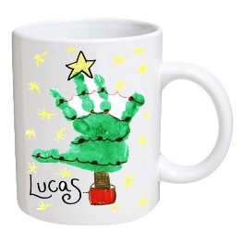
£5.50 per pack (School raises £1.40)
Mugs
Our ceramic mugs are printed with each child's festive design and printed with their name making a treasured gift. Bright white glazed ceramic 10oz mug with gift box.
£6.50 each (School raises £2.00)
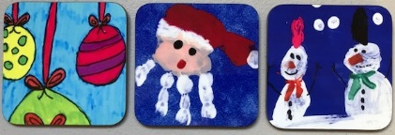
Coasters
These high quality gloss-finish coasters, are personalised with the child’s drawing. Perfect for putting your drinks on in style. White, high gloss, board backed. 90mm x 90mm
£3.00 each (School raises 50p)
Set of 4 Coasters (same design) £11.00 (School raises £1.50)
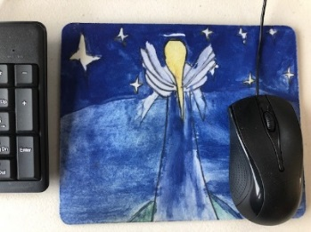
Mouse Mats
A unique personalised gift. With a non-skid rubber backing and soft fabric top this mouse mat allows smooth operation of the cursor whilst keeping the desk protected. 190mm x 230mm
£5.50 each (School raises £1.00)
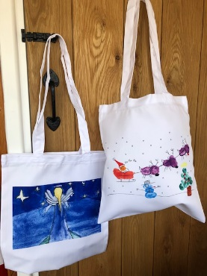
Shopping Tote Bag
Our fabulous white, long handled shopping tote bags are printed with the child’s very own drawing. Can easily be folded to fit into a handbag or pocket. Looks great and is eco-friendly as can be used again and again! Measures approx. 35cm x 40cm.
£8.00 each (School raises £2.00)

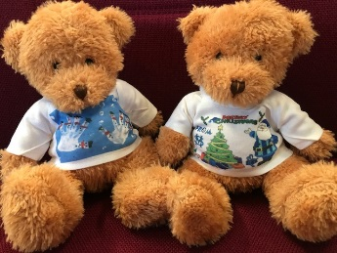
Teddies with Printed T-shirt
A cuddly plush teddy bear with printed t-shirt featuring the child’s festive picture. The teddies measure 20cm seated, have embroidered eyes and are suitable from birth.
£8.00 each (School raises £1.50)

All you need to do is encourage your child to create their design on the accompanying Drawing Sheet/Order Form and send it back to the school on or before
Tuesday 3rd November 2020

with payment to be made via cash (in an envelope) or cheque payable to Friends of Wreningham School

Please kindly fill out your Child's Name, Class and Order Quantities CLEARLY and in BLOCK CAPITALS as shown on the Drawing Sheet. If you wish to you can assist your child with their picture so that you are both happy with the design! If you need some inspiration, please have a look at www.rudolphcards.co.uk and Rudolph can give you a few design tips and ideas in his on-line Gallery!
It is VERY IMPORTANT that you only use Felt-tip pens or Water-based Paints. Please Note - no glitter or stuck on collage can be accepted!
Thank you in anticipation of your support with this Fundraiser and we look forward to seeing all the lovely artwork so that we can send it off and get the personalised items back in time for Christmas!
Kind regards
Kate Furborough (TA Class 1)
On behalf of,
Friends of Wreningham School

