Class 3 October Half Term Homework

A huge thank you for the amazing shields produced at home last week. The children are so proud of them and we had great fun using them to trial out Roman army formations.

Singing
Learn songs that we will be singing at the Cathedral so that you no longer need the word sheets. I have downloaded the music that we will be singing onto the Class 3 page of the school website. These were recorded by Posy, from Norwich School.
Please continue to read over the holiday.

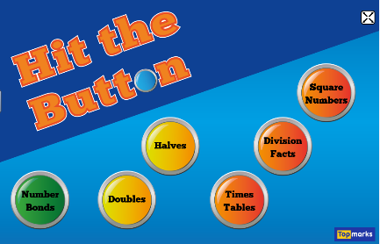
Maths
In class we have used the website below to practise our tables and division facts. It would be great if you could continue to practise these over the holidays.

http://www.topmarks.co.uk/maths-games/hit-the-button

Reminder
Wednesday 4th November we will be visiting the Norwich Castle Museum for our Roman Day. You will need to wear your uniform and bring a packed lunch. School drop off and pick up will be as normal.

Have a wonderful half term!

