

Calculation Policy
Wreningham V.C. Primary school

This policy contains the key pencil and paper procedures that we recommend be taught within the school across Key Stages 1 and 2. It has been written to ensure consistency and progression throughout the school. As children progress at different rates, some may need to use the strategies from previous or future year groups.

Although the focus of this policy is on written recording, it is important to recognise that the ability to calculate mentally lies at the heart of written calculations. During Key Stage One, emphasis is placed upon developing the skills of mental calculation. However mental calculation is not at the exclusion of written recording; it is complementary to it. In every written method there is an element of mental processing. All pupils will be given regular opportunities to record and explain their mathematical thinking.

The policy concentrates on the introduction of standard symbols, the use of the empty number line as a jotting to aid mental calculation and on the introduction of pencil and paper procedures. It is important that children do not abandon jottings and mental methods once pencil and paper procedures are introduced. Children will always be encouraged to look at a calculation/problem and decide the best method to use; pictures, mental calculation with or without jottings, structured recording or a calculator.

The long-term aim is for children to be able to select an efficient method of their choice whether this be mental, written or in upper Key Stage 2 using a calculator, that is appropriate for a given task. They will do this by always asking themselves:

‘Can I do this in my head?’
‘Can I do this in my head using drawings or jottings?’
‘Do I need to use a pencil and paper procedure?’
‘Do I need a calculator?’

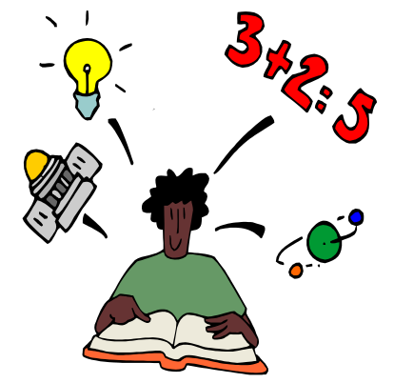

Addition
Reception & Year 1 Year 2 Year 3

National Numeracy Strategy:
Calculations

24–29 Understanding addition and subtraction
25 Extend understanding of the operation addition. Use and begin to read the related vocabulary. Use the +, – and = signs to record mental additions in a number sentence, and recognise the use of a symbol such as  or  to stand for an unknown number. Recognise that addition can be done in any order.
27 Understand that more than two numbers can be added. Begin to add three single-digit numbers mentally or three two-digit numbers with the help of apparatus (totals up to 100).
25, 29 Understand that subtraction is the inverse of addition (subtraction reverses addition).

32–41 Mental calculation strategies (+ and –)
33 Use knowledge that addition can be done in any order to do mental calculations more efficiently.
add three small numbers by putting the largest number first and/or find a pair totalling 10; partition into ‘5 and a bit’ when adding 6, 7, 8 or 9, then recombine; partition additions into tens and units, then recombine.
33 Identify near doubles, using doubles already known
35 Add/subtract 9 or 11: +/- 10 and adjust by 1.
Begin to add/subtract 19 or 21: +/- 20 and adjust by 1.
35 Use patterns of similar calculations.
35 State the subtraction corresponding to a given addition, and vice versa.
37, 39 Use known number facts and place value to add/subtract mentally.
41 Bridge through 10 or 20, then adjust.

National Numeracy Strategy:
Calculations

24–29 Understanding addition and subtraction
24 Understand the operation of addition and use the related vocabulary. Begin to recognise that addition can be done in any order.
Begin to use the +, – and = signs to record mental calculations in a number sentence, and to recognise the use of symbols such as or  to stand for an unknown number.
26 Begin to recognise that more than two numbers can be added together.

32–41 Mental calculation strategies (+ and –)
32 Use knowledge that addition can be done in any order to do mental calculations more efficiently; begin to partition into ‘5 and a bit’ when adding 6, 7, 8 or 9, then recombine (e.g. 6 + 8 = 5 + 1 + 5 + 3 = 10 + 4 = 14).
32 Identify near doubles, using doubles already known
34 Add 9 to single-digit numbers by adding 10 then subtracting 1.
34 Use patterns of similar calculations (e.g. 10 – 0 = 10, 10 – 1 = 9, 10 – 2 = 8…).
36, 38 Use known number facts and place value to add or subtract a pair of numbers mentally within the range 0 to at least 10, then 0 to at least 20.
40 Begin to bridge through 10, and later 20, when adding a single-digit number.

National Numeracy Strategy:
Calculations

24–29 Understanding addition and subtraction
25 Extend understanding of the operation of addition, read and begin to write the related vocabulary, and continue to recognise that addition can be done in any order. Use the +, – and = signs.
27 Extend understanding that more than two numbers can be added; add three or four single-digit numbers mentally, or three or four two-digit numbers with the help of apparatus or pencil and paper.
25, 29 Extend understanding that subtraction is the inverse of addition.

32–41 Mental calculation strategies (+ and –)
33 Use knowledge that addition can be done in any order to do mental calculations more efficiently. Add three or four small numbers by putting the largest number first and/or by finding pairs totalling 9, 10 or 11; partition into ‘5 and a bit’ when adding 6, 7, 8 or 9; partition into tens and units, then recombine
33 Identify near doubles, using doubles already known
35 Add and subtract mentally a ‘near multiple of 10’ to or from a two-digit number.
35 Use patterns of similar calculations.
35 Say or write a subtraction statement corresponding to a given addition statement, and vice versa.
37, 39 Use known number facts and place value to add/subtract mentally.
41 Bridge through a multiple of 10, then adjust.

42–45 Pencil and paper procedures (+ and –)
43, 45 Use informal pencil and paper methods to support, record or explain HTU + TU, HTU + HTU. Begin to use column addition for HTU + TU where the calculation cannot easily be done mentally.

Addition
Reception & Year 1 Year 2 Year 3

+ = signs and symbols & missing numbers
Continue using a range of equations as in Year 1 but with appropriate, larger numbers. Extend to
14 + 5 = 10 + + = 9
5 + 4 = = 5 + 4

Adding three numbers 1 + + 5 = 17
32 + + = 100 35 = 1 + + 5

Jottings: Partition into tens and ones and recombine
12 + 23 = 10 + 2 + 20 + 3
= 30 + 5
= 35

Number lines
23 + 12 = 23 + 10 + 2
= 33 + 2
= 35
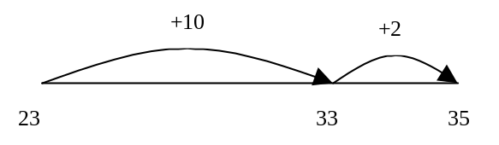

Add 9 or 11 by adding 10 and adjusting by 1
35 + 9 = 44

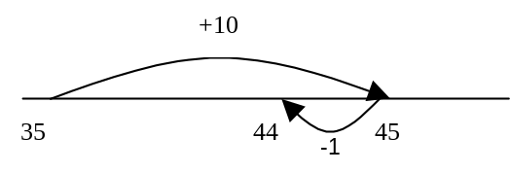
100 Square
When adding 2 digit numbers use 100 square, find number and move down column vertically. Eventually this will be done mentally.
34+10=44

+ = signs and symbols & missing numbers
Continue using a range of equations as in Year 1 and 2 but with appropriate, larger numbers.
13 + 6 = = 13 + 6
+ = 19

Partition into tens and ones and recombine
Partition both numbers and recombine.
Refine to partitioning the second number only e.g.

Number Line

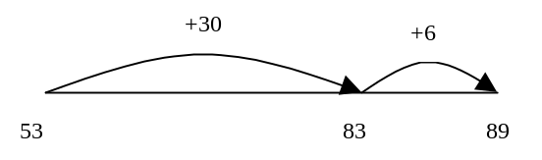

Add/subtract a near multiple of 10 to a two-digit number
Continue as in Year 2 but with appropriate numbers

Adding 19 or 21 by adding 20 and adjusting by 1
e.g. 35 + 19 is the same as 35 + 20 – 1.

e.g 45 + 21
45 + 20 + 1
65 + 1
66

e.g. 23 + 19
23 + 20 – 1
43 – 1
42

+ = signs and symbols & missing numbers

3 + 4 = = 3 + 4
3 + = 7 7 = + 4
+ 4 = 7 7 = 3 +
+ ∇ = 7 7 = + ∇

Pictures / marks

To count and add together sets of real objects and pictures.

3+2=5

 +

There are 7 people on the bus. 8 more get on.
How many people are on the bus?



Number Lines
To add one or several more onto a number line

8+1=9 +1

0 1 2 3 4 5 6 7 8 9

To be able to add through 10

8+5=13 +2 +3

0 1 2 3 4 5 6 7 8 9 10 11 12 13

To know addition can be done in any order.
3+9 and 9+3 =12

36 + 53
30 + 50 = 80
6 + 3 = 9
80 + 9 = 89
36 + 53
53 + 30 + 6
= 83 + 6
= 89

Addition
Year 4 Year 5 Year 6

National Numeracy Strategy:
Calculations

34–37 Understanding addition and subtraction
34 Consolidate understanding of relationship
between + and –. Understand the principles the of the commutative and associative laws as they apply or not to addition and subtraction.
40–47 Mental calculation strategies (+ and –)
40 Count on/back in repeated steps of 1,10 or 100. Partition into tens and units, adding the tens first. Identify near doubles, using known doubles Add/subtract the nearest multiple of 10, then adjust.
42 Continue to use the relationship between +/-.
42 Add 3 or 4 small numbers, finding pairs
totalling 10, or 9 or 11. Add three two-digit
multiples of 10.
44, 46 Use known number facts and place value to add or subtract mentally, including any pair of two-digit whole numbers

48–51 Pencil and paper procedures (+ and –)
48 Use informal pencil and paper methods to
support, record or explain additions. Develop and refine written methods for: column addition of two whole numbers less than 1000, and addition of more than two such numbers;
money calculations (for example, £7.85 ± £3.49).

National Numeracy Strategy:
Calculations

40–47 Mental calculation strategies (+ and –)
41 Partition into H, T and U, adding the most
significant digits first.
41 Identify near doubles, such as 1.5 + 1.6.
41 Add or subtract the nearest multiple of 10 or 100, then adjust.
43 Develop further the relationship between addition and subtraction.
43 Add several numbers (e.g. four or five single
digits, or multiples of 10 such as 40 + 50 + 80).
45, 47 Use known number facts and place value
for mental addition and subtraction (e.g.
470 + 380, 7.4 + 9.8).

48–51 Pencil and paper procedures (+ and –)
49 Use informal pencil and paper methods to
support, record or explain additions. Extend
written methods to: column addition of two integers less than 10000; addition of more than two integers less than 10000; addition of a pair of decimal fractions, both with one or both with two decimal places (e.g. £29.78 + £53.34).
National Numeracy Strategy:
Calculations

40–47 Mental calculation strategies (+ and –)
41 Consolidate all strategies from previous year,
including: add or subtract the nearest multiple of 10, 100 or 1000, then adjust; use the relationship between addition and subtraction; add several numbers.
45, 47 Use known number facts and place value
to consolidate mental addition/subtraction
(e.g 470 + 380, 7.4 + 9.8).

48–51 Pencil and paper procedures (+ and –)
49 Use informal pencil and paper methods to
support, record or explain additions. Extend written methods to column addition of numbers involving decimals.

Addition
Year 4 Year 5 Year 6

+ = signs and missing numbers
Continue using a range of equations as in Year 1 and 2 but with appropriate numbers.

Partition into tens and ones and recombine
Either partition both numbers and recombine or partition the second number only e.g.
55 + 37 = 55 + 30 + 7 or
= 85 + 7
= 92
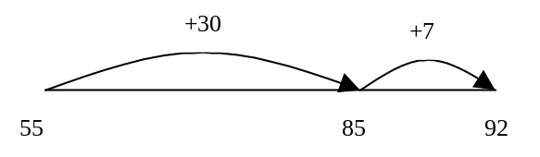

Add the nearest multiple of 10, then adjust

Continue as in Year 2 and 3 but with appropriate numbers e.g. 63 + 29 is the same as 63 + 30 - 1

Pencil and paper procedures
358 + 73 = 431

154
+ 32
186

Leading to carrying
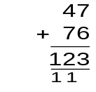

Extend to decimals in the context of money. Use a calculator to carry out one-step and two step calculations.

+ = signs and missing numbers
Continue using a range of equations as in Year 1 and 2 but with appropriate numbers.

Partition into hundreds, tens and ones and recombine
Either partition both numbers and recombine or partition the second number only e.g.

358 + 73 = 358 + 70 + 3 or 300 + 0 = 300
= 428 + 3 50 + 70 = 120
= 431 8 + 3 = 11
431

Add or subtract the nearest multiple of 10 or 100, then adjust
Continue as in Year 2, 3 and 4 but with appropriate numbers e.g. 458 + 79 = is the same as 458 + 80 - 1

Pencil and paper procedures
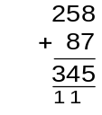
Extend to numbers with at least four digits
3587 + 675 = 4262

3587
+ 675
4262
111

Revert to expanded methods if the children experience any difficulty.

Extend to decimals (same number of decimals places) and adding several numbers (with different numbers of digits).

Use a calculator to carry out one-step and two step calculations involving all four operations

+ = signs and missing numbers
Continue using a range of equations as in Year 1 and 2 but with appropriate numbers.

Partition into hundreds, tens, ones and decimal fractions and recombine
Either partition both numbers and recombine or partition the second number only e.g.

35.8 + 7.3 = 35.8 + 7 + 0.3
= 42.8 + 0.3
= 43.1

Add the nearest multiple of 10, 100 or 1000, then adjust
Continue as in Year 2, 3, 4 and 5 but with appropriate numbers including extending to adding 0.9, 1.9, 2.9 etc

Pencil and paper procedures

Extend to numbers with any number of digits and decimals with 1 and 2 decimal places.
124.9 + 117.25 = 242.15

124.9
+ 117.25
242.15
1 1
Revert to expanded methods if the children experience any difficulty.



Use a calculator to solve problems involving
multi-step calculations

50 + 30 = 80
5 + 7 = 12
80 + 12 = 92

Subtraction
Reception & Year 1 Year 2 Year 3

Subtraction Objectives

During their time in Reception, children experience subtraction in a practical manner. We physically take away objects and count how many we have left.

Subtraction can be approached in various ways e.g. "five little speckled frogs" using children to act out the song and represent the subtraction taking place.

Towards the end of the Foundation Stage we represent our physical taking away actions using number sentences. We also reverse this process and illustrate number sentences physically, and on paper.

During Year One children continue to use practical methods to subtract but also begin to record their findings in a more formal manner.

Calculations
24–29 Understanding addition and subtraction
28 Understand the operation of subtraction (as ‘take away’, ‘difference’, and ‘how many more to make’), and use the related vocabulary.
Begin to use the +, – and = signs to record mental calculations in a number sentence, and to recognise the use of symbols such as  or  to stand for an unknown number.

32–41 Mental calculation strategies (+ and –)
34 Use patterns of similar calculations (e.g. 10 – 0 = 10, 10 – 1 = 9, 10 – 2 = 8…).
36, 38 Use known number facts and place value to add or subtract a pair of numbers mentally within the range 0 to at least 10, then 0 to at least 20.

Subtraction Objectives

Calculations
24–29 Understanding addition and subtraction
29 Extend understanding of the operation of subtraction, read and begin to write the related vocabulary. Use the +, – and = signs.
25, 29 Extend understanding that subtraction is the inverse of addition.

32–41 Mental calculation strategies (+ and –)
33 Find a small difference by counting up from the smaller to the larger number (e.g. 102 – 97).
35 Add and subtract mentally a ‘near multiple of 10’ to or from a two-digit number… by adding or subtracting 10, 20, 30… and adjusting.
35 Use patterns of similar calculations.
35 Say or write a subtraction statement corresponding to a given addition statement, and vice versa.
37, 39 Use known number facts and place value to add/subtract mentally.

42–45 Pencil and paper procedures (+ and –)
43, 45 Use informal pencil and paper methods to support, record or explain HTU ± TU, HTU ± HTU. Begin to use column addition and subtraction for HTU ± TU where the calculation cannot easily be done mentally.

Subtraction Objectives

We recognise that there are two subtraction models; "taking away" and “finding the difference between two numbers by counting on”.

As a school we promote the counting on method for informal strategies using a number line.

Calculations
24–29 Understanding addition and subtraction
29 Extend understanding of the operation of subtraction. Use and begin to read the related vocabulary. Use the +, – and = signs to record mental additions and subtractions in a number sentence, and recognise the use of a symbol such as  or  to stand for an unknown number.
Recognise that addition can be done in any order, but not subtraction: for example, 3 + 21 = 21 + 3, but 21 – 3 does not equal 3 – 21.
25, 29 Understand that subtraction is the inverse of addition (subtraction reverses addition).

32–41 Mental calculation strategies (+ and –)
33 Find a small difference by counting up from the smaller to the larger number (e.g. 42 – 39).
35 Add/subtract 9 or 11: add/subtract 10 and adjust by 1. Begin to add/subtract 19 or 21: add/subtract 20 and adjust by 1.
35 Use patterns of similar calculations.
35 State the subtraction corresponding to a given addition, and vice versa.
37, 39 Use known number facts and place value to add/subtract mentally.

Subtraction
Reception & Year 1 Year 2 Year 3

To be able to take away real objects

5 - 2 = 3



We made 6 cakes. We ate 2 of them.
How many cakes are left?

Year 1
Sam spent 4p. What was his change from 10p?



How many steps do you have to count back from 11 to get to 7? 4 steps

0 1 2 3 4 5 6 7 8 9 10 11 12

Recording by - drawing jumps on prepared lines, count back - constructing own lines

- = signs and symbols & missing numbers
7 - 3 =   = 7 - 3
7 -  = 4 4 =  - 3
 - 3 = 4 4 = 7 - 
 - ∇ = 4 4 =  - ∇

There were 17 bean bags in a bucket.
Luke took 9.How many bags were left?

- = signs and missing numbers
Continue using a range of equations as in Year 1 but with appropriate numbers.
Extend to 14 + 5 = 20 - 

Subtract 2 two digit numbers by finding the difference through counting on an empty number line

42 – 39 = 3
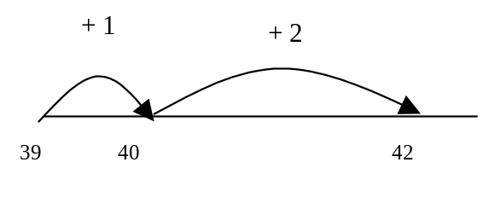

45 – 23 = 22

+7 +10 +5

23 30 40 45

Subtract 9 or 11. Begin to add/subtract 19 or 21
35 – 9 = 26

35 – 10 = 25
25 + 1 = 26

When subtracting 10 from 2 digit numbers use 100 square, find number and move up column vertically. Eventually this will be done mentally
34 – 10 = 24

Use known number facts and place value to subtract
37 - 12
37 - 10 = 27
27 - 2 = 25

- = signs and missing numbers
Continue using a range of equations as in Year 1 and 2 but with appropriate numbers.

Find a difference by counting up
Continue as in Year 2 but with appropriate numbers e.g. 102 – 97 = 5

Subtract mentally a ‘near multiple of 10’ to or from a two-digit number
Continue as in Year 2 but with appropriate numbers e.g. 78 – 49 is the same as 78 – 50 + 1

Use known number facts and place value to subtract
Continue as in Year 2 but with appropriate numbers e.g.

97 – 25 = 72

Find the difference 84-7
84-7 = 84-4 = 80-3= 77

Pencil and paper procedures
Complementary addition
84 – 56 = 28

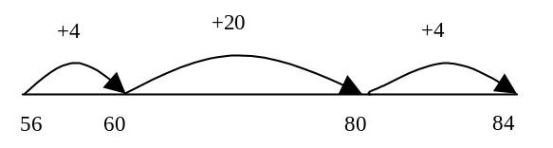

Subtraction
Year 4 Year 5 Year 6

Subtraction Objectives

Calculations
34–37 Understanding addition and subtraction
36 Consolidate understanding of relationship
between + and –. Understand the principles (not
the names) of the commutative and associative
laws as they apply or not to addition and
subtraction.
40–47 Mental calculation strategies (+ and –)
40 Find a small difference by counting up (e.g. 5003 – 4996). Count on or back in repeated steps of 1,10 or 100. Add or subtract the nearest multiple of 10, then adjust.
42 Continue to use the relationship between addition and subtraction.
44, 46 Use known number facts and place
value to add or subtract mentally, including
any pair of two-digit whole numbers.

48–51 Pencil and paper procedures (+ and –)
50 Use informal pencil and paper methods to
support, record or explain subtractions.
Develop and refine written methods for:
column subtraction of two whole numbers less than 1000; money calculations (for example, £7.85 ± £3.49).

Subtraction Objectives

Calculations
40–47 Mental calculation strategies (+ and –)
41 Find differences by counting up through next
multiple of 10, 100 or 1000, e.g. calculate
mentally a difference such as 8006 – 2993.
41 Add or subtract the nearest multiple of 10 or 100, then adjust.
43 Develop further the relationship between addition and subtraction.
45, 47 Use known number facts and place value
for mental addition and subtraction (e.g. 810 – 380, 9.2 – 8.6).

48–51 Pencil and paper procedures (+ and –)
51 Use informal pencil and paper methods to
support, record or explain subtractions. Extend
written methods to: column subtraction of two
integers less than 10000;addition or subtraction
of a pair of decimal fractions, both with one or
both with two decimal places.
Subtraction Objectives

Calculations
40–47 Mental calculation strategies (+ and –)
43 Consolidate all strategies from previous year,
including; find a difference by counting up; add or
subtract the nearest multiple of 10, 100 or 1000,
then adjust; use the relationship between addition
and subtraction.
45, 47 Use known number facts and place value
to consolidate mental addition/subtraction (e.g
810 – 380, 9.2 – 8.6).

48–51 Pencil and paper procedures (+ and –)
51 Use informal pencil and paper methods to
support, record or explain subtractions. Extend written methods to column subtraction of numbers involving decimals.

Subtraction
Year 4 Year 5 Year 6

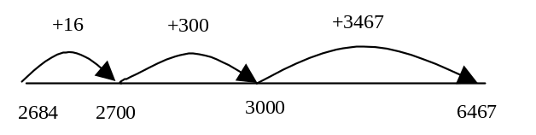
- = signs and missing numbers
Continue using a range of equations as in Year 1 and 2 but with appropriate numbers.

Find a small difference by counting up
e.g. 5003 – 4996 = 7
This can be modelled on an empty number line (see complementary addition below).

Subtract the nearest multiple of 10, then adjust.
Continue as in Year 2 and 3 but with appropriate numbers.

Pencil and paper procedures
Complementary addition 74 - 27 =

754 – 86 = 668

This first step can be done as 86 + 4=90 +10 = 100 etc…

Summer Term Year 4

Begin to use compact column subtraction with support (Modelling this may involve partitioning numbers into hundreds, tens and units/ones).

287-
164
123

- = signs and missing numbers
Continue using a range of equations as in Year 1 and 2 but with appropriate numbers.

Find a difference by counting up
e.g. 8000 – 2785 = 5215
This can be modelled on an empty number line (see complementary addition below).

Subtract the nearest multiple of 10, 100 or 1000,
then adjust
Continue as in Year 2, 3, 4 and 5 but with appropriate numbers.

Pencil and paper procedures
Complementary addition
6467 – 2684 = 3783

OR
6467 – 2684 = 3783

5 131
6467
2684
3783

- = signs and missing numbers
Continue using a range of equations as in Year 1 and 2 but with appropriate numbers.

Find a difference by counting up
e.g. 8006 – 2993 = 5013
This can be modelled on an empty number line (see complementary addition below).

Subtract the nearest multiple of 10 or 100, then adjust.
Continue as in Year 2, 3 and 4 but with appropriate numbers.

Pencil and paper procedures

Complementary addition
754 – 286 = 468

6 141
754 -
286
468

Column Subtraction:
1.Line up numbers in columns.
2.Estimate answer.
3.Subtract units (if top number is smaller exchange from tens).
4.Subtract tens (if top number is smaller exchange from hundreds).
5.Subtract hundreds. CHECK ANSWER

Using this method children will be able:

to subtract numbers with different numbers of digits;

know that decimal points should line up with each other

This calculation should be read as: Take 4 from 7; Take 60 from 80; Take one hundred from two hundred

Some children will progress further and will complete column subtraction with decimals.

Multiplication
Reception & Year 1 Year 2 Year 3

Solve practical problems that involve combining groups of 2, 5 and 10, or sharing into equal groups.

Multiplication Objectives

Calculations

46–51 Understanding multiplication and division
47 Understand the operation of multiplication as repeated addition or as describing an array. Use and begin to read the related vocabulary. Use the x, ÷ and = signs to record mental calculations in a number sentence, and recognise the use of a symbol such as  or  to stand for an unknown number.

47, 49 Know and use halving as the inverse of doubling.

54–57 Mental calculation strategies (x and ÷)
57 Use known number facts and place value to carry out mentally simple multiplications.

Tables taught each day, either as the mental oral starter or at other times.

Multiplication Objectives

Calculations
46–51 Understanding multiplication and division
47 Understand multiplication as repeated
addition. Read and begin to write the related vocabulary. Extend understanding that multiplication can be done in any order.
49 Recognise that division is the inverse of multiplication, and that halving is the inverse of doubling.

54–57 Mental calculation strategies (x and ÷)
55 To multiply by 10/100, shift the digits one/two places to the left.
55 Use doubling or halving, starting from known facts (e.g. 8 x 4 is double 4 x 4).
55 Say or write a division statement corresponding to a given multiplication statement.
57 Use known number facts and place value to carry out mentally simple multiplications.

Multiplication
Reception & Year 1 Year 2 Year 3

Pictures / marks

How many wheels do we need to make three lego cars?



Year 1

There are 3 sweets in one bag.
How many sweets are there in 5 bags?



Children will experience equal groups of objects and will count in twos and tens.

They will work on practical problem solving activities involving equal sets.
x = signs and symbols & missing numbers
7 x 2 =   = 2 x 7
7 x  = 14 14 =  x 7
 x 2 = 14 14 = 2 x 
 x ∇ = 14 14 =  x ∇

There are 4 apples in one box. How many apples in 6 boxes?

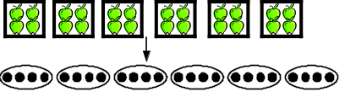

Arrays and repeated addition

-    4 x 2 or 4 + 4
-   
2 x 4 or 2 + 2 + 2 + 2

Arrays provide the opportunity to introduce inverse of multiplication 15 ÷ 3 = 5 and 15 ÷ 5 = 3

Children will also learn that multiplication is

commutative – can be calculated either way round.

For example, children should know that 3 X 5 has the

same answer as 5 X 3.

Doubling multiples of 5 up to 50
15 x 2 = 30

Double 15 by Partition

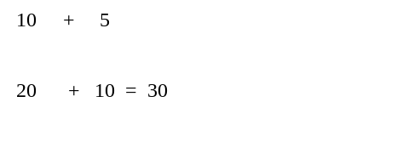

x = signs and symbols & and missing numbers
Continue using a range of equations as in Year 2 but with appropriate numbers.
6 x 5 = = 5 x 6

x = 30 Extend to: 4 x 3 = x 2

Jottings: Arrays and repeated addition
Continue to understand multiplication as repeated addition and continue to use arrays (as in Year 2).

 6 x 3 or 3 x 6

3 x 6 = 3 + 3 + 3 + 3 + 3 + 3

The grid/box method

Children could model a multiplication calculation using an array. This knowledge will support with the development of the grid method. The grid/box method is the natural progression from showing multiplications as arrays.

35 x 2 = 70

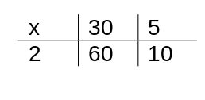

Use known facts and place value to carry out simple multiplications 32 x 3 = 96
Use the same method as above (partitioning), e.g.

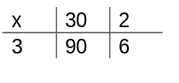
Doubling multiples of 5 up to 50

Answer = 70

Answer = 96

Multiplication
Year 4 Year 5 Year 6

Multiplication Objectives (excluding rapid recall)

Calculations
52–57 Understanding multiplication and division
52, 54 Extend understanding of the operations of x and ÷, and their relationship to each other and to + and –. Understand the principles (not the names) of the commutative, associative and distributive laws as they apply to multiplication.

60–65 Mental calculation strategies (x and ÷)
60 Use doubling or halving, starting from known facts. For example: double/halve two-digit numbers by doubling/halving the tens first; to multiply by 4, double, then double again; to multiply by 5, multiply by 10 then halve; find the 8 times-table facts by doubling the 4 times-table;
62 Use closely related facts (e.g. to multiply by 9
or 11, multiply by 10 and adjust; develop the x6
table from the x4 and x2 tables).
62 Partition (e.g. 23 x 4 = (20 x 4) + (3 x 4)).
62 Use the relationship between x and ÷
64 Use known number facts and place value to
multiply and divide integers, including by 10 and then 100 (whole-number answers).
66–69 Pencil and paper procedures (x and ÷)
66 Approximate first. Use informal pencil and
paper methods to support, record or explain
multiplications. Develop and refine written
methods for TU x U.

Multiplication Objectives (excluding rapid recall)

Calculations
52–57 Understanding multiplication and division
53, 55 Understand the effect of and relationships
between the four operations, and the principles (not the names) of the arithmetic laws as they apply to multiplication. Begin to use brackets.

60–65 Mental calculation strategies (x and ÷)
61 Use doubling or halving, starting from known facts.
For example: double/halve any two-digit number by
doubling/halving the tens first; double one number and
halve the other; to multiply by 25, multiply by 100 then
divide by 4; find the x16 table facts by doubling the x8
table; .
61 Use factors (e.g. 8 x 12 = 8 x 4 x 3).
63 Use closely related facts (e.g. multiply by 19 or 21 by multiplying by 20 and adjusting; develop the x12 table from the x10 and x2 tables).
63 Partition (e.g. 47 x 6 = (40 x 6) + (7 x 6)).
63 Use the relationship between multiplication and division.
65 Use known facts and place value to multiply and divide mentally.
66–69 Pencil and paper procedures (x and ÷)
67 Approximate first. Use informal pencil and paper methods to support, record or explain multiplications.
Extend written methods to: short multiplication of
HTU or TU by U; long multiplication of TU by TU;

Multiplication Objectives (excluding rapid recall)

Calculations
52–57 Understanding multiplication and division
53, 55 Understand and use the relationships between the four operations, and the principles (not the names) of the arithmetic laws. Use brackets.

60–65 Mental calculation strategies (x and ÷)
61 Use related facts and doubling or halving. For
example: double or halve the most significant digit first;
to multiply by 25, multiply by 100 then divide by 4;
double one number and halve the other; find the x24 table by doubling the x6 table twice.
61 Use factors (e.g. 35 x 18 = 35 x 6 x 3).
63 Use closely related facts: for example, multiply by
49 or 51 by multiplying by 50 and adjusting. Develop the x 17 table by adding facts from the x 10 and x 7 tables.
63 Partition (e.g. 87 x 6 = (80 x 6) + (7 x 6)
63 Use the relationship between x and ÷.
65 Use known number facts and place value to consolidate mental multiplication and division.

66–69 Pencil and paper procedures (x and ÷)
67 Approximate first. Use informal pencil and paper
methods to support, record or explain multiplications.
Extend written methods to: multiplication of ThHTU by
U (short multiplication); short multiplication of
numbers involving decimals; long multiplication of a three-digit by a two-digit integer;

Multiplication
Year 4 Year 5 Year 6

x = signs and missing numbers
Continue using a range of equations as in Year 2 but with appropriate numbers

Use the grid method of multiplication (as below)

Pencil and paper procedures

Grid method – multiplying TU X U

Children begin by working out an approximate answer so that they get a sense of what is a reasonable answer

23 x 7 (Number sentence from a worded problem)

23 x 7 is approximately 20 x 10 = 200

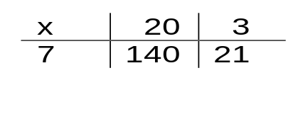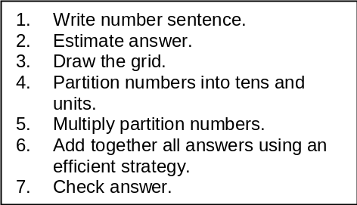

Children should learn times tables facts for all times tables up to 12 x 12

Children should learn times tables facts for all times tables up to 12 x 12
x = signs and missing numbers
Continue using a range of equations as in Year 2 but with appropriate numbers

Use the grid method of multiplication

Pencil and paper procedures

Grid method – multiplying TU x TU or HTU by U
72 x 38 is approximately 70 x 40 = 2800

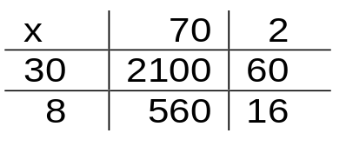

56 x 27 is approximately 56 x 27 = 1800

20 7
50 | 1000 | 350
6 | 120 | 42

Compact method
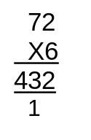
Extend to simple decimals with one decimal place

Extend to simple decimals with one decimal place (Year 6).

x = signs and missing numbers
Continue using a range of equations as in Year 2 but with appropriate numbers

Use the grid method of multiplication (as below)

Pencil and paper procedures
Grid method - multiplying HTU x TU, U.t x U, U.t x U.t
372 x 24 is approximately 400 x 20 = 8000

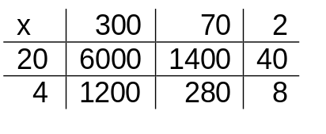

Extend to decimals with up to two decimal places.

Compact method
37
X 24
148
740
888

= 2160
= 576
2736
=7440
=1488
8928

= 161

=1350

= 162
1512

Division
Reception & Year 1 Year 2 Year 3

Division Objectives (excluding rapid recall)

Calculations
46–51 Understanding multiplication and division
49 Begin to understand division as grouping (repeated subtraction) or sharing. Use and begin to read the related vocabulary. Use the x, ÷ and = signs to record mental calculations in a number sentence, and recognise the use of a symbol such as  or  to stand for an unknown number.
47, 49 Know and use halving as the inverse of doubling.

54–57 Mental calculation strategies (x and ÷)
57 Use known number facts and place value to carry out mentally simple divisions.

Division Objectives (excluding rapid recall)

Calculations
46–51 Understanding multiplication and division
49 Understand division as grouping (repeated subtraction) or sharing. Read and begin to write the related vocabulary.
Recognise that division is the inverse of multiplication, and that halving is the inverse of doubling.
51 Begin to find remainders after simple division.
51 Round up or down after division, depending on the context.

54–57 Mental calculation strategies (x and ÷)
55 Use doubling or halving, starting from known facts (e.g. 8 x 4 is double 4 x 4).
55 Say or write a division statement corresponding to a given multiplication statement.
57 Use known number facts and place value to carry out mentally simple divisions.

Division
Reception & Year 1 Year 2 Year 3

Reception children learn to divide practically, in a variety of "real life" situations. They share counters amongst friends, mixture into cake cases and general equipment on a daily basis.

Towards the end of the Reception year the concept of halving is introduced in a practical way. Objects are divided in half physically, such as shapes made out of play-dough.

How many pairs of socks are there in the ‘launderette’?



In Year One the children continue to solve division problems practically and now illustrate their answers in ways that they find easy to understand before moving on to a more consistent approach. By the end of the year the children are introduced to division number sentences and the division symbol.

Vocabulary:
Share, half, divide into, group

÷ = signs and symbols & missing numbers

6 ÷ 2 =   = 6 ÷ 2
6 ÷  = 3 3 = 6 ÷ 
 ÷ 2 = 3 3 =  ÷ 2
 ÷ ∇ = 3 3 =  ÷ ∇

Halve numbers to 10/20-practically and mentally

Divide practically by sharing

Understand division as sharing and grouping
6 ÷ 2 can be modelled as:
Sharing – 6 sweets are shared between 2 people. How many do they have each?
 
●     

Grouping – There are 6 sweets. How many people can have 2 each? (How many 2’s make 6?)

Or 6 eggs shared between 2 nests = 3 eggs/ nest


12 children get into teams of 4 to play a game. How many teams are there?
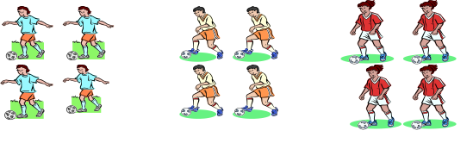
4 eggs fit in a box.
How many boxes would you need to pack 20 eggs?

÷ = signs and symbols & missing numbers
Continue using a range of equations as in Year 2 but with appropriate numbers.

 x 3 = 18 (How many 3’s in 18?)

Understand division as sharing and grouping
20 ÷ 5 can be modelled as:
Sharing – 20 shared between 5

20÷5 = 4 counters each (no counters left over)
1 2 3 4 5

9 sweets shared between 3 children
●        

   3 sweets each

OR
Grouping - How many 3’s go into 18?
Chairs are stacked in groups of 3. If there are 18 chairs, how many groups/stacks are there? 6 Groups
1 2 3 4 5 6
X X X X X X
X X X X X X
X X X X X X

Remainders
15 ÷ 4 Share counters evenly between 4. Count how many are left over
16 ÷ 3 = 5 r1
Sharing - 16 shared between 3, how many left over?
Grouping – How many 3’s make 16, how many left over?

OR

Division
Year 4 Year 5 Year 6

Division Objectives (excluding rapid recall)

Calculations
52–57 Understanding multiplication and division
52, 5 52, 54 Extend understanding of the operations of x and ÷, and their relationship to each other and to + and –.
56 Find remainders after division.
Divide a whole number of pounds by 2, 4, 5 or 10 to give £.p.
Round up or down after division, depending on the context.

60–65 Mental calculation strategies (x and ÷)
60 Use doubling or halving, starting from known facts. For example: double/halve two-digit numbers by doubling/halving the tens first;
to multiply by 5, multiply by 10 then halve; find quarters by halving halves.
62 Use the relationship between multiplication and division.
64 Use known number facts and place value to multiply and divide integers, including by 10 and then 100 (whole-number answers).
66–69 Pencil and paper procedures (x and ÷)
68 Approximate first. Use informal pencil and paper methods to support, record or explain divisions. Develop and refine written methods for TU ÷ U.

Division Objectives (excluding rapid recall)

Calculations
52–57 Understanding multiplication and division
53, 55 Understand and use the relationships between the four operations. Use brackets.
57 Express a quotient as a fraction or as a decimal rounded to one decimal place. Divide £.p by a two-digit number to give £.p.
Round up or down after division, depending on the context.

60–65 Mental calculation strategies (x and ÷)
61 Use related facts and doubling or halving. For
example: double or halve the most significant digit
first; to multiply by 25, multiply by 100 then divide
by 4; double one number and halve the other.
63 Use the relationship between multiplication
and division.
65 Use known number facts and place value to
consolidate mental multiplication and division.

66–69 Pencil and paper procedures (x and ÷)
69 Approximate first. Use informal pencil and paper methods to support, record or explain divisions. Extend written methods to: short division of TU or HTU by U (mixed-number answer); division of HTU by TU (long division, whole-number answer); short division of numbers involving decimals.
Division Objectives (excluding rapid recall)

Calculations
52–57 Understanding multiplication and division
53, 55 Understand the effect of and relationships between the four operations. Begin to use brackets.
57 Begin to express a quotient as a fraction, or as
a decimal when dividing a whole number by 2, 4,
5 or 10, or when dividing £.p. Round up or down
after division, depending on the context.

60–65 Mental calculation strategies (x and ÷)
61 Use doubling or halving, starting from known facts.
For example: double/halve any two-digit number by
doubling/halving the tens first; double one number and
halve the other; to multiply by 25, multiply by 100 then
divide by 4; find sixths by halving thirds.
63 Use the relationship between multiplication and
division.
65 Use known facts and place value to multiply and divide mentally.
66–69 Pencil and paper procedures (x and ÷)
69 Approximate first. Use informal pencil and paper methods to support, record or explain divisions. Extend written methods to: short division of HTU by U (with integer remainder).

Division
Year 4 Year 5 Year 6

÷ = signs and missing numbers
Continue using a range of equations as in Year 2 but with appropriate numbers.

Sharing and grouping
Continue to understand division as both sharing and grouping (repeated subtraction).

Remainders
Quotients expressed as fractions or decimal fractions
676 ÷ 8 = 84.5

119
2
3 358 r 1/3 Answer 119 r1/3

Some children will progress further and will:

Use the short compact method of division to divide by two digit-numbers
÷ = signs and missing numbers
Continue using a range of equations as in Year 2 but with appropriate numbers.

Sharing and grouping
30 ÷ 6 can be modelled as:
sharing – sharing among 6, the number given to each person
grouping – groups of 6 taken away and the number of groups counted e.g.

x 6 = 30

Remainders
41 ÷ 4 = 10 r1

Divide on a number line with a remainder
37 ÷ 7 How many 7’s in 37

1 2 3 4 5 +2

0 7 14 21 28 35 37

Answer 5 r 2

Pencil and paper procedures

Chunking

72 ÷ 5

72
- 50 (10 x 5)
22
- 20 (4 x 5)
2 Answer 14 remainder 2

÷ = signs and symbols & missing numbers
Continue using a range of equations as in Year 2 but with appropriate numbers.

Sharing and grouping
Continue to understand division as both sharing and grouping

Remainders
Quotients expressed as fractions or decimal fractions
61 ÷ 4 = 15 ¼ or 15.25

Compact Method HTU ÷ U

- ÷ 5

105
2
5 528 r3 Answer 105 r3

119
2
3 358 r1 Answer 119 r1

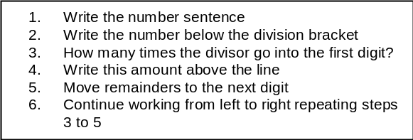

Take away chunks of the divisor until you cannot take away any more

