Barry the fish with fingers
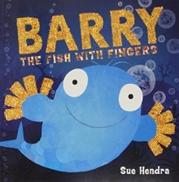
Click here to hear the story being read by Mrs Furness

Reading
Task 1: 'Barry was no ordinary fish'. What does 'ordinary' mean?

Task 2: Can you spot any verbs or adjectives while you are reading?

Task 3: Have a go at this 60 second read. Please read the guidance first.
Guidance
60 second read

Writing
Here is a booklet with checklists you can use to see what you should be aiming for when you are writing. Scroll through to find the correct year group and you can try to tick the boxes off when you are working on a piece of writing. This checklist is used in school for assessed independent pieces of writing but it can be used at home as a guide.

Task 1: Puffy, the puffer fish, blows bubbles.
Think of different words to describe bubbles.
You might try blowing bubbles to help you think of some new vocabulary.

Task 2: Can you write a new adventure for Barry and his friends?
You could use a story mountain or story planner to organise your ideas.
Try to use some new vocabulary that you have seen over the past few weeks in our ‘Under the sea’ themed books.

Task 3: Design your own interesting sea creature and write a fact file about it.
You might like to use one of these templates. There is a sea themed one on page 3.
Task 4: Handwriting
Topic
Task 1: Design a new scarf for Puffy which has repeating patterns on it.
You can make your own or use this worksheet.

Task 2: Look at the features of different creatures.
How do these help them live in their particular habitats?
How are they adapted to live there?
Here is a powerpoint about animals who live in the Antarctic.
Think about how they are adapted to live in this environment.

Task 3: Try some finger painting like Barry does!
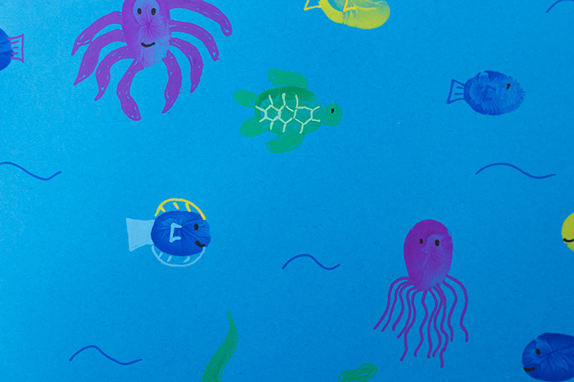

Task 4: Design a new animal that has some body parts from different creatures. (Link to writing task 3)

Task 5: Puffy, the puffer fish, can blow the best bubbles.
Think about your talents... what are you good at doing?
What are your friends' talents?

